**MP Practical- 5**

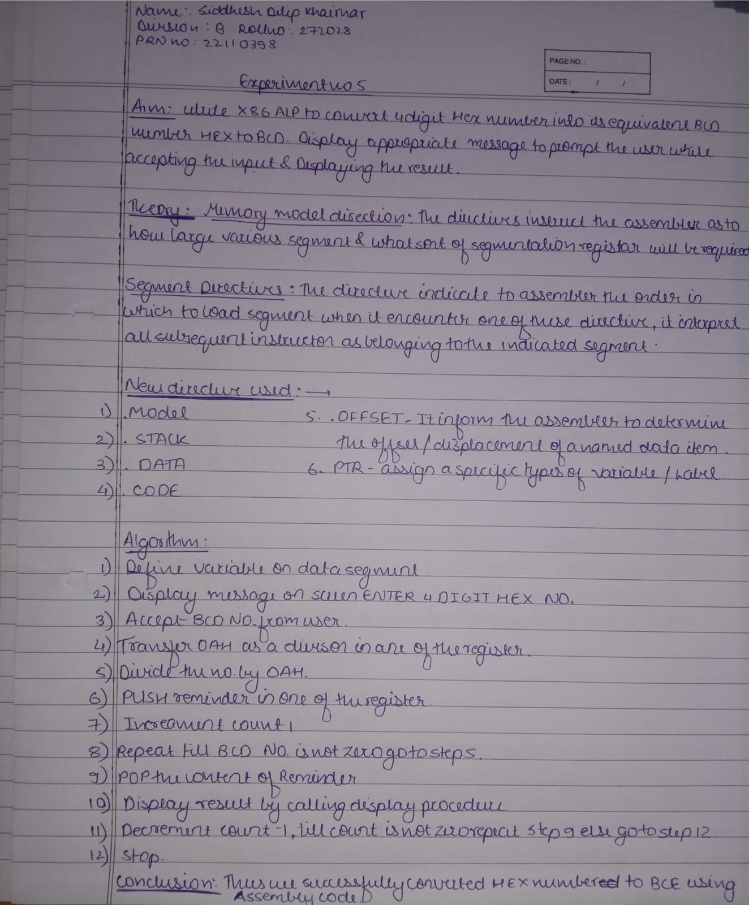

**Code:**

global _start

_start:

section .text

; macro for system call for write

%macro disp 2

mov rax,1

mov rdi,1

mov rsi,%1

mov rdx,%2

syscall

%endmacro

; macro for system call for read

%macro accept 2

mov rax,0

mov rdi,0

mov rsi,%1

mov rdx,%2

syscall

%endmacro

;---------First Choice Hex to BCD----------------

ch1:

; accept numbers

disp msg1,len1

accept num,02

call convert

mov [no.1],al

accept num,03

call convert

mov [no.2],al

disp msg2,len2

; Form ax as input

mov ah,[no.1]

mov al,[no.2]

;Point esi to predefined array in .data

mov esi,array1

; Hex to BCD conversion

l5:

mov dx,0000h

mov bx,[esi]

div bx

mov [rem],dx

mov [t1],al

push rsi

call disp_proc

pop rsi

inc esi

inc esi

mov ax,[rem]

dec byte[cnt]

jnz l5

disp msg,len

;To exit program.

ch3:

mov rax,60

mov rdi,0

syscall

;CONVERT procedure

convert:

mov esi,num

mov al,[esi]

cmp al,39h

jle l1

sub al,07h

l1: sub al,30h

rol al,04h ;to swap number

mov bl,al

inc esi

mov al,[esi]

cmp al,39h

jle l2

sub al,07h

l2: sub al,30h

add al,bl

mov [t1],al

ret

;CONVERT2 procedure

convert2:

mov al,[num]

cmp al,39h

jle l8

sub al,07h

l8:sub al,30h

ret

;DISPLAY procedure

disp_proc:

;for unt's place

mov al,[t1]

cmp al,09h

jle l4

add al,07h

l4:add al,30h

mov [t2],al

disp t2,1

ret

;DISPLAY@ procedure

display2:

mov rsi,charans+3

mov rcx,04h

l12: mov rdx,0

mov rbx,10h

div rbx

cmp dl,09h

jle l3

add dl,07h

l3:add dl,30h

mov [rsi],dl

dec rsi

dec rcx

jnz l12

mov rax,1

mov rdi,1

mov rsi,charans

mov rdx,4

syscall

ret

section .data

msg: db "",10

len: equ $-msg

msg1: db "Enter Hex number : ",10

len1: equ $-msg1

msg2: db "BCD equivalent is : ",10

len2: equ $-msg2

msg3: db "#####MENU#####",10

db "1.Hex to BCD.",10

db "2.BCD to Hex.",10

db "3.Exit.",10

len3: equ $-msg3

msg4: db "Enter your choice : ",10

len4: equ $-msg4

msg5: db "Enter BCD number : ",10

len5: equ $-msg5

msg6: db "Hex equivalent is : ",10

len6: equ $-msg6

array1 dw 2710h,03E8h,0064h,000Ah,0001h

cnt db 5

cnt2 db 5

section .bss

num resb 03

no.1 resb 02

no.2 resb 02

t1 resb 03

t2 resb 03

t3 resb 03

rem resw 02

result resw 03

choice resb 03

charans resb 08

**Output:**

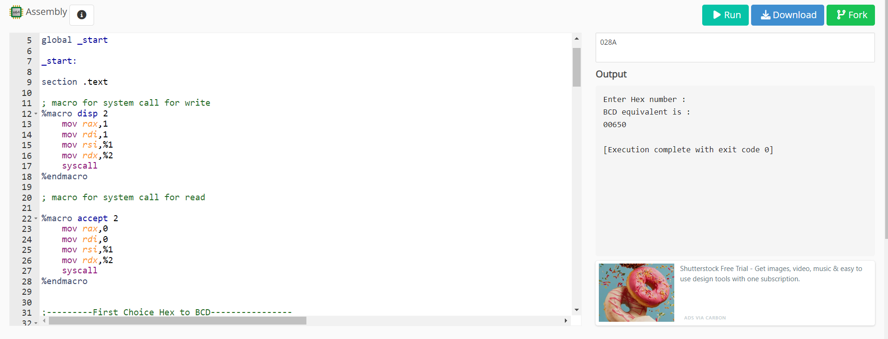

Name- Siddhesh Dilip Khairnar

Roll No.- 272028

Batch- B2